ORDINANCE NO. 9 8 2026
AN ORDINANCE OF THE ANNETTA SOUTH CITY COUNCIL AMENDING THE ZONING ORDINANCE OF THE CITY OF ANNETTA SOUTH, TEXAS, BY CHANGING THE ZONING CLASSIFICATION OF CERTAIN PROPERTY WITHIN THE CITY, BEING APPROXIMATELY 10.473 ACRES OF LAND SITUATED IN THE Y.R. YERION SURVEY, ABSTRACT NO. 1696 COMMONLY KNOWN AS FIELD ESTATES LOCATED AT 7006 S. FM 5, PARKER COUNTY, ANNETTA SOUTH, TEXAS, FROM SINGLE-FAMILY 1 “SF-1” TO PLANNED DEVELOPMENT DISTRICT 1 “PD-1” WITH CERTAIN SINGLE-FAMILY DETACHED DWELLING AND PERSONAL ACCESSORY USES; PROVIDING FOR THE AMENDMENT OF THE OFFICIAL ZONING MAP TO REFLECT SUCH CHANGE; PROVIDING THAT THIS ORDINANCE SHALL BE CUMULATIVE OF ALL ORDINANCES; PROVIDING A SAVINGS CLAUSE; PROVIDING FOR A PENALTY CLAUSE; PROVIDING A SEVERABILITY CLAUSE; PROVIDING FOR PUBLICATION IN THE OFFICIAL NEWSPAPER; AND PROVIDING AN EFFECTIVE DATE.
WHEREAS, the City of Annetta South, Texas (the “City”) is a Type A general law municipality located in Parker County, created in accordance with the provisions of Chapter 6 of the Local Government Code and operating pursuant to the enabling legislation of the State of Texas; and
WHEREAS, pursuant to Chapter 211 of the Local Government Code, the City has adopted a comprehensive zoning ordinance and map regulating the location and use of buildings, other structures, and land for business, industrial, residential, or other purposes, for the purpose of promoting the public health, safety, morals, and general welfare, all in accordance with the City’s comprehensive plan; and
WHEREAS, a zoning classification of the Property identified below was requested by a person or entity having a proprietary interest in said Property, and has requested a zoning classification change on the Property from its current classification of Single-Family 1 (“SF-1”) to Planned Development 1 (“PD-1”); and
WHEREAS, in accordance with the City’s Zoning Ordinance, the owners of the property described as being approximately 10.473 acres of land in the Y.R. Yerion Survey, Abstract No. 1696, Parker County, Texas, as more fully described in Exhibit “A” attached hereto and incorporated herein (the “Property”), have filed an application to change the zoning from Single-Family 1 (“SF-1”) to Planned Development District 1 (PD-1) with Single-Family Detached Dwelling and personal accessory uses; and
WHEREAS, the proposed PD-1 is structured not to allow commercial use;
WHEREAS, a public hearing was duly held by the Planning and Zoning Commission of the City on September 8 2026 and by the City Council of the City on September 8, 2026 with respect to the zoning change described herein; and
WHEREAS, all requirements of law dealing with notice to other property owners, publication, and all procedural requirements have been complied with in accordance with City Ordinances and Chapter 211 of the Local Government Code; and
WHEREAS, the City Council of the City does hereby deem it advisable and in the public interest to amend the Zoning Ordinance, as amended, as described herein, and the amendment will promote the health, safety, and general welfare of the citizens of the City and the general public.
NOW, THEREFORE, BE IT ORDAINED BY THE CITY COUNCIL OF THE CITY OF ANNETTA SOUTH, TEXAS, THAT:

SECTION 1.
The Zoning Ordinance and Zoning Map of the City of Annetta South, as amended, are hereby amended on the hereinafter described property and area to establish a Planned Development District 1 as shown below:
Approximately 10.473 acres of land situated in the Y.R. Yerion Survey, Abstract No. 1696 commonly known as Field Estates located at 7006 S. FM 5, Parker County, Annetta South, Texas, described in Exhibit “A,” attached hereto.

SECTION 2.
The Site Plan, and Development Standards of the proposed Planned Development District No. 1 (PD-1), attached hereto as Exhibits “B,” “C,” “D,” each incorporated herein for all purposes allowed by law, are hereby approved as the Development Standards, Conceptual Site Plan, and Conceptual Renderings for this Planned Development District No. 1 (PD-1). The Property shall be subject to and developed in accordance with the Development Standards, Conceptual Site Plan, and Conceptual Renderings as approved by the City Council upon recommendation of the Planning and Zoning Commission, and all other applicable ordinances of the City. All development standards and regulations not specifically set forth herein shall be those required for development in the PD Zoning District as set forth in the relevant sections of the City's Zoning Ordinance, except as otherwise amended herein.

SECTION 3.
The official Zoning Map of the City is hereby amended and the City Secretary is directed to revise the official Zoning Map to reflect the approved Planned Development District No. 1 (PD-1), as set forth above.

SECTION 4.
The use of the Property hereinabove described shall be subject to all the applicable regulations contained in the Zoning Ordinance of the City, as amended, to the regulations, restrictions, terms, and conditions set forth in this Ordinance, and to all other applicable and pertinent ordinances of the City.

SECTION 5.
This Ordinance shall be cumulative of all provisions of ordinances and of the Code of Ordinances, City of Annetta South, Texas, as amended, except where the provisions of this Ordinance are in direct conflict with the provisions of such ordinances and such code, in which event the conflicting provisions of such ordinances and such code are hereby repealed as they apply to this Property.

SECTION 6.
All rights and remedies of the City are expressly saved as to any and all violations of the provisions of any ordinances governing zoning or land use that have accrued at the time of the effective date of this Ordinance; and, as to such accrued violations and all pending litigation, both civil and criminal, whether pending in court or not, under such ordinances, same shall not be affected by this Ordinance but may be prosecuted until final disposition by the courts.

SECTION 7.
Any person, firm, or corporation who violates, disobeys, omits, neglects, or refuses to comply with or who resists the enforcement of any of the provisions of this Ordinance shall be fined not more than Two Thousand Dollars ($2,000.00) for each offense. Each day that a violation is permitted to exist shall constitute a separate offense.

SECTION 8.
It is hereby declared to be the intention of the City Council that the sections, paragraphs, sentences, clauses, and phrases of this Ordinance are severable, and if any section, paragraph, sentence, clause, or phrase of this Ordinance shall be declared invalid or unconstitutional by the valid judgment or decree of any court of competent jurisdiction, such invalidity or unconstitutionality shall not affect any of the remaining sections, paragraphs, sentences, clauses, and phrases of this Ordinance, since the same would have been enacted by the City Council without the incorporation in this Ordinance of any such invalid or unconstitutional section, paragraph, sentence, clause, or phrase.

SECTION9.
The City Secretary of the City is hereby directed to publish this Ordinance in compliance with state law.

SECTION 10.
This Ordinance shall be in full force and effect from and after its passage and publication as required by law, and it is so ordained.
PASSED AND APPROVED THIS______ DAY OF _____________, 2026.

CITY OF ANNETTA SOUTH, TEXAS

______________________________
David Goolsby, Mayor
ATTEST:

___________________________
Ellen Woodward, City Secretary

EXHIBIT A - PROPERTY DESCRIPTION

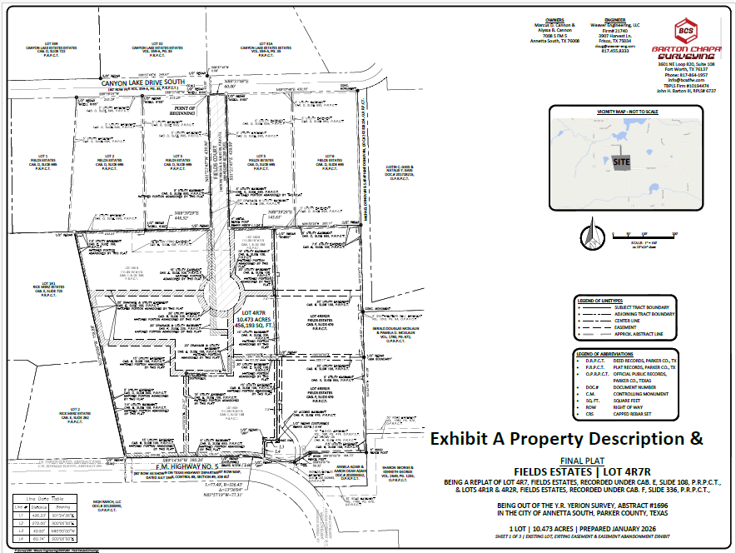

EXHIBIT B –SITE PLAN

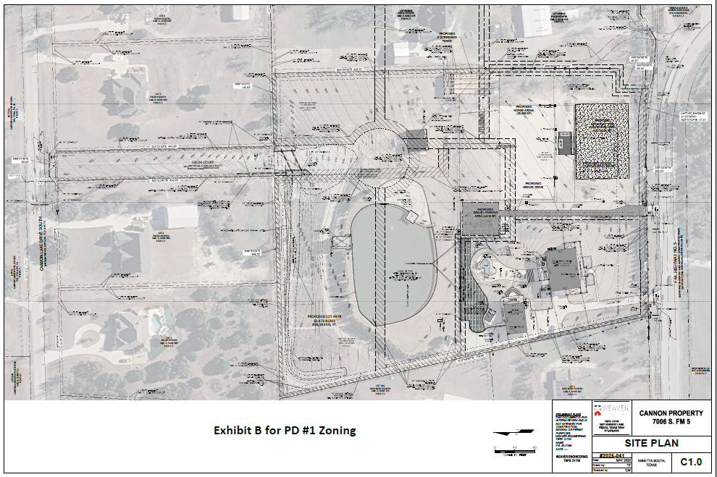

EXHIBIT C – PLANNED DEVELOPMENT STANDARDS

Proposed Planned Development Standards
Definitions: As per the Annetta South Zoning Ordinance 2018-4-10
Conflicts: In case of a conflict between the PD #1 and the Zoning Ordinance the Zoning Ordinance will control.
Exhibits: Site Plan C1 Date May 2026 Weaver Engineering
Plat Final Plat/Replat Lot 4R7 Fields Estates – Sheet 3 of 3 January 2026
Legal Description Sheet 3 of Final Plan – January 2026 Barton Chapa Surveying
Perimeter Fence Plan May 2026, Weaver Engineering
General Standards recommended for PD #1:
- Permitted Uses
1)Single Family Detached Dwelling
2) Home based business or occupation within the single-family detached dwelling.
3) Accessory uses customarily associated with the single-family detached dwelling and limited to:
- Motor vehicle garage limited to use of owner of dwelling and limited in size to 2,500 sf.
- Covered Carport for use of owners of dwelling limited in size to 1,000 sf.
- Guest outdoor temporary event parking of gravel limited in size to 5,000 sf.
- Swimming Pool for private use only.
- Pool Equipment Storage Shed limited in size to no more than 1,000 sf.
- Football field area with artificial turf limited in size to 20,000 sf.
- Horse arena area limited in size to 30,000 sf.
- Club house for viewing of arena and football field limited in size to 1,200 sf.
- Loafing shed limited in size to 560 sf with paddock and holding area limited in size to 3,500 sf both with a screening fence of wood or stone of 8-foot height along the side yard extending beyond the loafing shed and paddock holding area 25 feet in length.
- Agricultural storage shed limited to 1,500 sf
- Conditional Uses
- Additional Accessory uses subject to the approval of the City Council and within the required side yard with an additional stormwater drainage analysis defining and confirming the required capacity of the existing stormwater drainage system.
- Outdoor illumination provided the illumination does not exceed 0.25 footcandles beyond the property line.
- Site Design
- Required minimum lot area shall be 5 acres.
- Required minimum side and rear yard shall be15 feet.
- Required minimum side yard required for allowable non-residential or agricultural use shall be 30 feet unless 8 feet in height screening wall of wood or stone is place at the 15-foot side yard and extended a minimum of 25 feet before and after the use.
- Maximum building height shall be 30 feet for principal use and 20 feet for accessory uses.
- Required minimum front yard for all principal and accessory building/structure uses shall be 60 feet.
- Maximum lot coverage shall be 50 percent.
EXHIBIT D – PERIMETER FENCE PLAN
